National University of Computer & Emerging Sciences, Karachi
Spring-2022, FAST School of Computing
Re-Midterm-1 Examinations
March 29, 2022, 10:00 am – 11:00 am
Course Code: CS3001 | Course Name: Computer Networks
Instructor Name: Dr. Farrukh Salim , Dr. Aqsa Aslam, Mr. Shoaib Raza and Ms. Eman Shahid
Student Roll No: | Section:
Instructions:
- Return the question paper. Do not write anything on question paper, except your Roll # & Section #.
- Read each question completely before answering it. There are 4 questions and 2 pages.
- In case of any ambiguity, you may make assumptions. However, your assumptions should not contradict any statement in the question paper.
- All the answers must be solved according to the sequence given in the question paper.
- This paper is subjective. Write the answers only on answer sheet.

Time: 60 minutes. Max Points: 50

Question 1: [5 points]

In a given network as Figure 1, two hosts are communicating with each other. Each host is connected using the WiFi 802.11n (450Mbps) with the wireless access point. The wireless access points in turn are connected to the same single router using Fast Ethernet (100Mbps) connection. Assuming there is no other data communicating at the same time. Which one is (are) the bottlneck link(s) between Host-1 and Hsot-2 and why? What is (are) the data rate of the bottleneck link(s)?

Question 2: [10 points]
Suppose that each Wireless Access Point is at a distance of 200km from the Router (as shown in Figure 1). Further suppose that there is no node processing delay, nor queuing delay at any device. Moreover, also assume that there is no propagation delay between each host and its Access Point. The data rate is assumed to be 2Mbps between each host and Access Point and 10Mbps between each Access Point and the Router. Find the approximate end-to-end delay between Host-1 and Host-2 for a data packet of size 2Mbits.

Question 3: [5 * 3 = 15 points]

Make a table, that provides transport service requirements in terms of (i) data loss, (ii) throughput and (iii) time sensitiveness of minimum five (5) different network applications.

Question 4: [10 * 2 = 20 points]

For the result of the traceroute command shown below in Figure 2, give answers for below questions:
- If traceroute command runs again, will the IP address shown by point A will be always this same for google.com? If no, and any other IP address is also possible, then why?
- What this ‘30 hops’ represents?
- Which device is represented by the IP address of Point C in the network?
- What * represents?
- On running traceroute command, the result for this line shown by point E is always ‘Request timed out’. What could be the possible reason behind this?
- What these three different values represents? and why not only one value suffices?
- Why these values are mostly smaller than most of the values above? Give reason.
- What is the importance of this number 13 shown by point H?
- What this URL show by point H represents?
- Which type of Internet Control Message Protocol (ICMP) messages are used by traceroute ping command.

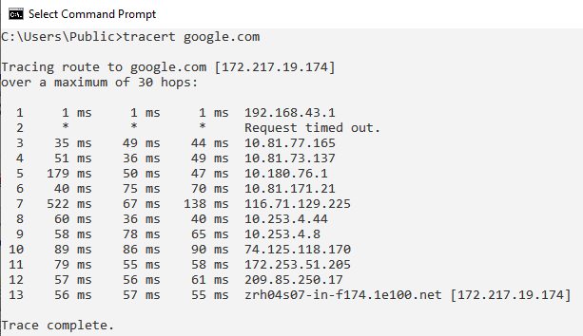
E
B
F
G
C
H
D
I
A

Figure 2

